DESIGN AND DEVELOPMENT OF PROJECT FALCON: A SOLAR-POWERED SMART BUOY FOR WAVE, WIND-SPEED, AND WIND-DIRECTION MONITORING WITH SHORT-TERM WAVE-HEIGHT PREDICTION

A Thesis Proposal

Presented to

The Faculty of the Electronics and Computer Technology Department

Fullbright College

In Partial Fulfillment of the

Requirements for the Degree

Bachelor of Science in Information Technology

By

John Ruzzel M. Correa

Mayla R. Bacaltos

Gina P. Caballero

Saira B. Caballero

Gwyn Isabel C. Enriquez

October 2026

APPROVAL SHEET
This thesis proposal entitled DESIGN AND DEVELOPMENT OF PROJECT FALCON: A SOLAR-POWERED SMART BUOY FOR WAVE AND WIND MONITORING WITH AI-ASSISTED SHORT-TERM PREDICTION prepared and submitted by the researchers in partial fulfillment of the requirements for the degree Bachelor of Science in Information Technology, has been examined and is recommended for oral defense.
Ronalyn May B. Ardael
Research Instructor
Engr. Jeff Gabayno, ECE and Jahmicah L. Estrella
Adviser
Approved in partial fulfillment of the requirements for the degree Bachelor of Science in Information Technology by the thesis examination committee, with a proposal rating of ____ and final oral rating of _____.
JUAN D. DELA CRUZ, PhD
Member
JUAN D. DELA CRUZ, PhD
Member
JUAN D. DELA CRUZ, PhD
Chairperson
Accepted and approved as partial fulfillment of the requirements for the degree of Bachelor of Science in Information Technology.
Ronalyn May B. Ardael
Dean

ACKNOWLEDGMENT

The researchers would like to express their sincere gratitude to everyone who contributed to the completion of this thesis proposal.

The researchers are grateful to their thesis adviser, research instructor, dean, and panel members for their guidance, recommendations, and encouragement throughout the preparation of this study. Their comments helped improve the research design, system concept, and evaluation plan.

The researchers also thank the individuals who provided technical suggestions and assistance during the planning of the Project FALCON prototype.

Finally, the researchers express their appreciation to their families and friends for their patience, moral support, and continuous encouragement.

The Researchers

Table of Contents
APPROVAL SHEET | 2
ACKNOWLEDGEMENT | 3
CHAPTER 1 INTRODUCTION | 5
1.1 Background of the Study | 5
1.1.1 International Context | 6
1.1.2 National Context | 7
1.1.3 Local Context | 9
1.2 Review of Related Literature | 10
1.2.1 Pressure-Based Wave Measurement | 11
1.2.2 Solar-Powered Buoy Operation | 11
1.2.3 IoT and Cloud-Based Environmental Monitoring | 12
1.2.4 AI-Assisted Short-Term Wave Prediction | 13
1.3 Review of Related Studies | 13
1.3.1 Local Studies | 13
1.3.2 Foreign Studies | 14
1.3.3 Synthesis of Research Gap | 16
1.4 Theoretical and Conceptual Framework | 16
1.4.1 Theoretical Framework | 17
1.4.3 Conceptual Paradigm | 19
1.5 Significance of the Study | 22
1.6 Statement of the Problem | 23
CHAPTER 2 METHODOLOGY | 25
2.1 Research Design/ Project Development Methodology | 25
2.1.1 Developmental Research Design | 25
2.1.2 Experimental Evaluation | 26
2.1.3 Iterative SDLC Using the Prototyping Model | 26
2.2 System Architecture / Framework | 29
Conceptual Framework | 30
Testing Rubrics | 31
System Overview | 33
System Design and Architecture | 36
System Flowchart | 36
2.3 Data Collection Method | 38
2.4 Software and Tools Used | 40
Tools for Testing and Developing the Project | 42
2.5 Development Procedures | 43
2.6 Testing and Evaluation | 44
2.7 Ethical Considerations | 48
References | 50

CHAPTER 1

INTRODUCTION

Background of the Study
Coastal environments are influenced by waves and wind. Monitoring wave height, wind speed, and 0°–360° wind direction provides useful information for understanding coastal conditions. Global ocean observations are important for weather, climate, and environmental monitoring, but gaps in coverage still remain (Intergovernmental Oceanographic Commission of UNESCO [IOC-UNESCO], 2025).
Recent technologies such as sensors, microcontrollers, wireless communication, solar power, and cloud platforms make smaller environmental monitoring systems possible. Reliable power is essential for continuous buoy operation, and McLeod and Ringwood (2022) reported that batteries and solar panels are commonly used to power data buoys. This supports the solar-battery design of Project FALCON.
Wave conditions can be measured using underwater pressure sensors. Lyman et al. (2020) showed that pressure measurements can be used for wave monitoring when properly processed and validated. Based on this approach, Project FALCON will use a submersible pressure sensor to produce an estimated wave height and a separate wind sensor to measure wind speed and wind direction.
Project FALCON will integrate these sensors with an ESP32 microcontroller, GPS, wireless communication, and a cloud-based monitoring platform. Processed pressure data will produce estimated wave height, while the collected environmental data will support short-term wave-height prediction. During an internet interruption, the system will continue collecting and temporarily storing data locally; once the connection is restored, the stored records will be transmitted to the cloud. Hou et al. (2024) demonstrated that wave and wind data can be used for significant wave-height prediction using deep learning. Project FALCON will evaluate its prediction component through actual testing using data collected by the prototype.

International Context
International studies show that ocean monitoring depends on continuous observations, reliable sensors, dependable power, and effective data processing. The GOOS 2025 Status Report explains that ocean observations are important for forecasting, climate services, and environmental monitoring. However, the report also identifies gaps and uneven coverage in the global ocean observing system (IOC-UNESCO, 2025). This shows the continuing need for practical monitoring systems that can collect environmental data in coastal areas.
For buoy power, McLeod and Ringwood (2022) reported that batteries and solar photovoltaic systems are commonly used to support the operation of data buoys. Their findings support the solar-battery power system of Project FALCON. However, their study focused mainly on power options for data buoys rather than evaluating a complete system that combines wave and wind speed and 0°–360° wind direction monitoring, cloud-based data access, and AI-assisted prediction. Therefore, the actual power performance of Project FALCON must still be evaluated using its own hardware and testing conditions.
For wave monitoring, Lyman et al. (2020) demonstrated that underwater pressure measurements can be processed to measure wave conditions when the sensor is properly installed, calibrated, and validated. Their study supports the use of a submersible pressure sensor in Project FALCON. However, their work mainly focused on pressure-based wave measurement and did not combine this function with wind speed and 0°–360° wind direction monitoring, solar-powered operation, cloud-based monitoring, and AI-assisted short-term prediction in one system.
For wave prediction, Hou et al. (2024) demonstrated the use of wave and wind information in a deep-learning approach for significant wave-height prediction. Their work supports the use of environmental data for data-driven wave prediction. However, their study focused mainly on prediction using environmental datasets rather than developing a physical smart buoy that collects its own wave and wind measurements and uses the collected data for short-term prediction.
Research Gap and Unique Contribution
International studies establish the feasibility of pressure-based wave measurement, solar-powered buoy operation, and AI-based wave prediction, but they generally examine these functions separately. Project FALCON addresses this gap by integrating pressure-based estimated wave-height monitoring, wind speed and 0°–360° wind direction monitoring, GPS, solar-battery power, wireless communication, cloud-based monitoring, and short-term wave-height prediction in one student-scale prototype. Its contribution is the evaluation of how these established technologies perform together as a complete system.
Synthesis
The international context shows that ocean monitoring remains important, with the GOOS 2025 Status Report identifying continuing gaps in global ocean observations (IOC-UNESCO, 2025). Existing studies support pressure-based wave measurement (Lyman et al., 2020), solar-battery systems for data buoys (McLeod & Ringwood, 2022), and wave-height prediction using wave and wind data (Hou et al., 2024). Project FALCON builds on this foundation by integrating these functions with wind direction, GPS, wireless communication, and cloud monitoring in one student-scale prototype for local evaluation.

National Context
In the Philippines, coastal wave conditions vary according to location and season. Pacaldo, Bilgera, and Abundo (2022) assessed nearshore wave-energy resources around Cuyo Island, Palawan using wave and wind information together with the SWAN model. Their results showed differences in wave conditions between locations and monsoon seasons. This demonstrates the importance of considering local conditions when studying coastal waves.
However, Pacaldo et al. (2022) focused on nearshore wave-energy resource assessment using numerical modeling. Their study did not develop a physical smart buoy that directly collects pressure-based wave, wind speed, and 0°–360° wind direction measurements, transmits the collected data to a cloud platform, and uses the observations for short-term wave-height prediction. Project FALCON has a different purpose because it focuses on the development and actual testing of an integrated monitoring prototype.
DOST-ASTI has also developed meteorological buoy technology for environmental monitoring in the Philippines. Its buoy development demonstrates that locally developed systems can use environmental sensors and communication technologies for remote data collection. Its Metbuoy+ work continues the development of sensing, communication, and real-time environmental monitoring capabilities (Department of Science and Technology–Advanced Science and Technology Institute [DOST-ASTI], 2024).
The DOST-ASTI project provides an important national reference for buoy-based environmental monitoring. However, its purpose and system configuration are different from Project FALCON. The proposed study has a more specific student-scale scope centered on pressure-based estimated wave-height monitoring, wind speed and 0°–360° wind direction monitoring, solar-powered operation, cloud-based data access, and short-term wave-height prediction. Project FALCON is not intended to replace or compete with existing government monitoring systems.
Research Gap and Unique Contribution
The national research gap is not the absence of wave studies or buoy technology in the Philippines. Existing studies and projects already demonstrate wave assessment and environmental monitoring using buoy systems. However, the reviewed national sources do not evaluate the same student-scale combination proposed for Project FALCON. The unique contribution of the present study is the development and evaluation of a prototype that combines pressure-based wave monitoring, wind speed and 0°–360° wind direction monitoring, GPS, solar-battery power, wireless data transmission, cloud-based monitoring, and AI-assisted short-term prediction as one integrated system.
Synthesis
The national context confirms that wave assessment and buoy-based environmental monitoring are already present in the Philippines. Pacaldo et al. (2022) demonstrate the importance of location and seasonal conditions in wave assessment, while DOST-ASTI (2024) provides evidence of locally developed buoy technology. Project FALCON differs by evaluating a student-scale prototype that combines estimated wave-height monitoring, wind speed and 0°–360° wind direction, solar-powered operation, cloud monitoring, and short-term wave-height prediction.

Local Context
Puerto Princesa City, Palawan provides a relevant local setting for coastal monitoring research. Madarcos, Alcantara, and Creencia (2026) examined perceived climate-change impacts among coastal communities in Puerto Princesa City and reported that 69% of the participants perceived changes in wave intensity compared with ten years earlier. Their findings show that changes in coastal conditions are a concern among the communities included in the study.
However, the study of Madarcos et al. (2026) was based on community perceptions rather than direct measurements from environmental monitoring instruments. It did not directly measure wave height, wind speed, or wind direction using a deployed sensor system. This creates a relevant difference between reported or perceived changes in coastal conditions and the collection of actual sensor-based wave and wind observations.
Palawan has also been used for locally developed buoy technology. DOST-ASTI previously deployed meteorological buoy technology in Aborlan, Palawan, demonstrating the application of buoy-based environmental monitoring within the province (DOST-ASTI, 2024). However, the purpose and configuration of the existing system are different from those of Project FALCON. The present study specifically focuses on a student-scale smart buoy for wave and wind speed and 0°–360° wind direction monitoring with AI-assisted short-term prediction.
Project FALCON will use a submersible pressure sensor to collect water-pressure measurements for estimated wave-height monitoring. The pressure signal will pass through the required signal interface and analog-to-digital conversion before being processed by the ESP32. The collected pressure data will be calibrated, filtered, and processed before being used to produce an estimated wave height. A separate wind sensor will measure wind speed and 0°–360° wind direction, while GPS will provide the location of the buoy. These components are consistent with the planned equipment for the prototype.
The system will use solar panels and a rechargeable battery to support its operation. Environmental data will be transmitted through the available wireless connection to a cloud-based platform for storage, viewing, and analysis. If the internet connection is interrupted, data collection will continue and the records will be stored locally with their timestamps; after the connection is restored, the stored records will be transmitted to the cloud. The collected dataset will also be used to develop and evaluate the short-term wave-height prediction component.
The initial prediction component will use a transparent baseline method. Any trained AI model and related accuracy claim will require sufficient calibrated field data, chronological validation, and comparison with that baseline.
Research Gap and Unique Contribution
The local research gap is not the absence of coastal studies or buoy technology in Palawan. Instead, the reviewed local sources do not provide evidence on how the specific Project FALCON configuration will perform in Puerto Princesa City. Madarcos et al. (2026) focused on community perceptions rather than direct sensor-based wave and wind measurements, while the existing DOST-ASTI buoy technology has a different purpose and configuration. Therefore, there is a need within the scope of the reviewed sources to evaluate the proposed combination of pressure-based wave monitoring, wind speed and 0°–360° wind direction monitoring, GPS, solar-battery operation, wireless communication, cloud-based monitoring, and AI-assisted short-term prediction under the selected local testing conditions.
The unique contribution of Project FALCON at the local level is its integrated and site-based approach. The prototype will collect its own wave, wind speed, and 0°–360° wind direction observations instead of relying only on community perceptions, existing datasets, or numerical models. These observations will be transmitted to the cloud-based platform and used for monitoring and short-term wave-height prediction. The study will then evaluate the actual performance and limitations of the integrated prototype under the selected testing conditions in Puerto Princesa City, Palawan.
Synthesis
The local context shows the value of measurable coastal data in Palawan. Madarcos et al. (2026) provide evidence of community perceptions regarding changes in wave intensity in Puerto Princesa City, while DOST-ASTI (2024) demonstrates the use of buoy-based monitoring technology in Palawan. Project FALCON extends this context through direct estimated wave-height, wind speed, and 0°–360° wind direction monitoring integrated with solar power, GPS, wireless/cloud communication, and short-term wave-height prediction under selected local testing conditions.
1.2 Review of Related Literature
This section discusses the literature supporting the main technologies used in Project FALCON: pressure-based wave measurement, solar-powered buoy operation, IoT and cloud monitoring, and short-term wave-height prediction. These areas are directly connected to the intended functions of the proposed smart buoy.

1.2.1 Pressure-Based Wave Measurement
Pressure sensors are a practical option for measuring waves in nearshore areas because changes in water pressure can be related to changes in the water surface. Lyman et al. (2020) developed the Open Wave Height Logger, a low-cost pressure-sensor system for continuous wave measurement. Their field tests showed strong agreement with a commercial pressure-based wave recorder. This supports the use of a submerged pressure sensor as a source of wave data for Project FALCON.
Pressure readings, however, cannot be treated directly as wave height. Lyman et al. (2020) explained that the data must be corrected and processed using information such as atmospheric pressure, water depth, sensor position, and pressure attenuation. They also showed that deeper sensor placement can reduce the pressure signal produced by short-period waves. For Project FALCON, this means that sensor calibration, installation depth, sampling, filtering, and validation must be considered before pressure data are converted into wave-height estimates.
The literature therefore supports pressure-based wave monitoring while also defining its limits. Project FALCON will use the pressure sensor as the primary source for producing an estimated wave height, but the accuracy of the estimates will be determined through actual testing and comparison with suitable reference measurements.

1.2.2 Solar-Powered Buoy Operation
A smart buoy needs continuous electrical power for its sensors, controller, GPS, communication device, and data logging. Solar power is suitable for this type of system because the buoy is intended to operate outdoors for extended periods. Williams et al. (2025) developed a low-cost autonomous multi-functional buoy that used solar power, GPS, sensors, local logging, and satellite communication. Their field deployments showed that a compact solar-powered platform can support autonomous coastal monitoring and reliable data transmission.
Solar power alone does not guarantee continuous operation. The system must balance the energy produced by the solar panel with the energy used by the sensors, controller, communication system, and other components. Battery capacity is also important because the buoy must continue operating when sunlight is limited. For this reason, Project FALCON will monitor the performance of its solar-battery system during testing instead of assuming that the selected components will provide sufficient power. The proposal baseline is six compact 5 W panels (30 W total) with a 12.8 V 10 Ah LiFePO4 battery, BMS, LiFePO4-compatible charge controller, fuse, and regulated power branch; this configuration remains subject to measured-load and charging validation.
This literature supports the solar-powered design stated in the title of Project FALCON. It also shows that power performance should be treated as an evaluation area of the prototype, including charging behavior, battery condition, operating time, and the ability of the power system to support monitoring and communication during the test period.

1.2.3 IoT and Cloud-Based Environmental Monitoring
Internet of Things (IoT) technology allows environmental sensors to collect data and send them to a remote platform for storage and viewing. Trevathan and Schmidtke (2022) developed an open-source aquatic monitoring platform that combined sensors, a microcontroller, cellular communication, server-side storage, and an online dashboard. Their work shows how separate hardware and software components can be connected into one remote environmental monitoring system.
Low-cost buoy systems also show the value of automatic data collection and cloud storage. Giraldo et al. (2022) developed an open-source buoy for remote water-quality monitoring that periodically collected sensor measurements and transmitted them through a wireless network to a cloud service for storage and visualization. Although their monitored variables differ from Project FALCON, the study is relevant because it demonstrates the same basic data flow from sensors to a remote monitoring platform.
For Project FALCON, the ESP32 will receive pressure, wind speed, 0°–360° wind direction, GPS, and available system-status data. Records will be prepared for wireless transmission to the cloud-based platform and dashboard. During an internet interruption, data collection will continue and records will be buffered locally with their original timestamps, then transmitted after connectivity is restored. The reliability of transmission, local storage, recovery, cloud storage, and dashboard access will be evaluated using the actual prototype.

1.2.4 AI-Assisted Short-Term Wave Prediction
Machine learning can be used to identify patterns between wave conditions and environmental variables. Hasan et al. (2024) used wind speed, wind direction, wind gust, air pressure, temperature, and location information to predict significant wave height using several machine-learning models. Their results showed that wind and atmospheric variables can provide useful information for wave-height prediction, while performance can change when a model is applied to data from new locations.
Hou et al. (2024) developed a deep-learning model for significant wave-height prediction in the South China Sea. Their work shows that recent wave information can be used in data-driven prediction, but model performance depends on the quality of the data and the conditions represented during training. Shen et al. (2024) also reported that adding wind-field information improved significant wave-height prediction in a monsoon region, showing the value of considering the relationship between wind and waves.
These studies support the AI-assisted part of Project FALCON, but they do not guarantee that the proposed model will produce the same level of accuracy. Project FALCON will use the data available from its own monitoring system and will evaluate prediction results against actual observations and a selected baseline method. This makes the AI component an evaluated research function rather than an assumed capability.

1.3 Review of Related Studies
This section reviews recent local and foreign studies that are closely related to the design and evaluation of Project FALCON. The local studies establish the Philippine and Palawan context, while the foreign studies provide evidence for the sensing, IoT, buoy, and prediction technologies used in the proposed system. The section ends by identifying the specific research gap addressed by Project FALCON.

1.3.1 Local Studies
Pacaldo et al. (2022) assessed nearshore wave-energy resources around Cuyo Island, Palawan using wave and wind information and the SWAN model. Their analysis showed clear seasonal differences in wave height, wave period, wind speed, and direction, particularly between the northeast and southwest monsoons. The study is important to Project FALCON because it confirms that wave and wind conditions in Palawan change with location and season. This supports the need to record both wave and wind data and to limit conclusions to the actual site and period of testing.
The same study by Pacaldo et al. (2022) also showed differences between offshore wind information and observations from the PAGASA station in Cuyo. This indicates that measurements can vary depending on sensor location and exposure. For Project FALCON, this is relevant because the prototype is intended to collect local observations at its deployment site rather than assume that data from a distant source represent the exact conditions around the buoy.
DOST-ASTI (2024) documented the continued development of locally designed meteorological buoy technology in the Philippines. Its buoy development demonstrates the use of environmental sensors, communication systems, and remote data access for Philippine monitoring applications. This provides an important national technology reference for Project FALCON. However, Project FALCON has a narrower student-scale focus on pressure-derived estimated wave-height monitoring, wind speed and 0°–360° wind direction monitoring, solar power, cloud monitoring, and AI-assisted short-term prediction.
Madarcos et al. (2026) examined perceived climate-change impacts in coastal communities of Puerto Princesa City. Their study reported local perceptions of changes in wave intensity. Because the study was based on community perception, it does not provide direct instrument-based wave measurements. Its relevance to Project FALCON is therefore contextual: it shows local concern about coastal conditions and supports the value of collecting measurable wave, wind speed, and 0°–360° wind direction observations in Puerto Princesa City.
Taken together, these local studies show that wave, wind speed, and 0°–360° wind direction conditions are important in Palawan and that monitoring technology already exists in the Philippines. The need addressed by Project FALCON is not the absence of buoy systems. Instead, the study will evaluate how its specific low-cost integrated design performs under the selected local testing conditions.

1.3.2 Foreign Studies
Lyman et al. (2020) developed and tested the Open Wave Height Logger, an open-source pressure-based system for wave measurement. The system was compared with commercial instruments, and the pressure-derived wave measurements showed strong agreement under tested conditions. The study is directly related to Project FALCON because it provides evidence that submerged pressure measurements can be used to estimate wave characteristics when the sensor is properly installed, calibrated, processed, and validated.
Trevathan and Schmidtke (2022) developed an open-source IoT platform for remote aquatic environmental sensing. Their system integrated environmental sensors, a microcontroller, cellular communication, server storage, and an online dashboard. The study is related to Project FALCON because it demonstrates the complete path from field sensing to remote data access. It also supports the use of an IoT architecture for continuous environmental monitoring rather than treating the sensor, communication, and dashboard components as separate systems.
Giraldo et al. (2022) designed a low-cost buoy for remote water-quality monitoring in fish farming. Their prototype automatically collected sensor data and transmitted the measurements to a cloud service for storage and visualization. While the measured variables were different, the study shows that low-cost buoy platforms can support automatic sensing, wireless transmission, and remote monitoring. This is relevant to the hardware and cloud integration planned for Project FALCON.
Williams et al. (2025) developed a low-cost autonomous multi-functional buoy for coastal monitoring and particle tracking. The platform used solar power, GPS, environmental sensors, local logging, and satellite communication. Field deployments demonstrated successful autonomous operation and high data recovery and communication rates. This study is relevant to Project FALCON because it provides recent evidence that solar-powered, multi-sensor buoy platforms can operate as integrated monitoring systems in real coastal environments.
Hasan et al. (2024) developed machine-learning models for significant wave-height prediction using wind and atmospheric variables from buoy datasets. Their results showed strong performance on test data but lower performance when models were applied to new stations, highlighting the importance of evaluating generalization. This is relevant to Project FALCON because its AI-assisted prediction must be tested using data that are separate from the data used for model training.
Shen et al. (2024) developed a significant wave-height prediction model that combined wave-height information with wind-field data. Their results showed that including wind information improved prediction performance. This finding supports Project FALCON's decision to collect wind speed and 0°–360° wind direction together with wave-related data. However, the model and dataset used in that study are more complex than the proposed student-scale system, so Project FALCON must establish its own prediction performance through testing.

1.3.3 Synthesis of Research Gap
The reviewed literature and studies support the major parts of Project FALCON: pressure-based wave measurement, solar-powered buoy operation, IoT-based cloud monitoring, and short-term wave-height prediction using wave and wind data.
They also identify limitations that require actual prototype testing. Estimated wave height depends on sensor depth, calibration, and signal processing; solar operation depends on energy generation and load demand; wireless monitoring depends on communication availability and reliable data recovery; and AI prediction depends on data quality and the conditions represented during training.
The research gap is therefore not the absence of smart buoys, wave sensors, IoT monitoring, or machine-learning prediction. It is the development and evaluation of the exact Project FALCON configuration: a student-scale solar-powered smart buoy that combines pressure-based estimated wave-height monitoring, wind speed and 0°–360° wind direction monitoring, GPS, wireless cloud communication with local buffering and post-interruption transmission, a monitoring dashboard, and short-term wave-height prediction under selected conditions in Puerto Princesa City, Palawan.
Project FALCON will address this gap by evaluating estimated wave-height accuracy, wind data acquisition, communication and recovery after internet interruption, data storage, solar-battery operation, dashboard functionality and usability, and short-term prediction performance. The results will identify the prototype's capabilities, limitations, and areas for improvement.

1.4 Theoretical and Conceptual Framework
This section presents the foundational concepts and conceptual flow that guide the design, development, and evaluation of Project FALCON. It explains how the system combines environmental sensing, data communication, and artificial intelligence to monitor coastal conditions and estimate short-term changes in wave height.

1.4.1 Theoretical Framework
Project FALCON is guided by three foundational concepts: Internet of Things (IoT)-based environmental monitoring, pressure-based wave measurement with wind monitoring, and Artificial Intelligence (AI)-assisted short-term wave-height prediction. These concepts explain how the system gathers environmental measurements, makes the collected information accessible, and uses recorded data to estimate possible future wave conditions.
1. Internet of Things (IoT)-Based Environmental Monitoring
The Internet of Things (IoT) involves connecting physical devices, sensors, microcontrollers, and software platforms so that data can be collected, processed, and transmitted. In environmental monitoring, IoT allows measurements from remote locations to be accessed through a connected monitoring platform without requiring users to be physically present at the site.
In Project FALCON, the pressure and wind sensors will collect environmental measurements, while the ESP32 microcontroller will process the sensor readings and manage data transmission to a cloud-based dashboard. Users will then be able to view the available wave and wind information remotely. This concept supports the project's goal of providing accessible coastal data for monitoring and research.
2. Pressure-Based Wave Measurement and Wind Monitoring
Pressure-based wave measurement relies on changes in underwater pressure caused by the movement of waves. As waves pass over a submerged pressure sensor, the resulting pressure variations can be recorded and processed to estimate wave characteristics, including wave height. Lyman et al. (2020) demonstrated the use of pressure-sensor data logging for wave measurement. However, the reliability of the estimates depends on proper sensor installation, calibration, and data processing.
In Project FALCON, the pressure sensor will gather underwater pressure readings that will be processed to estimate wave height. A separate wind sensor will measure wind speed and wind direction. These measurements are useful because wind conditions can influence wave development, although the relationship also depends on factors such as water depth, shoreline characteristics, and local weather conditions. Together, the sensors will provide environmental data for monitoring and further analysis.
3. Artificial Intelligence (AI)-Assisted Short-Term Wave-Height Prediction
Artificial Intelligence (AI) enables computer systems to analyze data, identify patterns, and use those patterns to estimate future values. For short-term wave-height prediction, an AI model can learn from previously collected wave-height observations and use the learned patterns to predict wave heights over a defined future period.
In Project FALCON, the collected and processed wave-height estimates will serve as the primary data for developing and evaluating a short-term prediction model. The predicted values will be compared with observed estimates to determine how accurately the model forecasts wave-height changes. The model's performance will depend on the quality and quantity of available data and the prediction method used. Therefore, the predictions will be treated as estimates to support coastal observation and research, rather than replacements for official marine forecasts or warnings.
Overall, these three foundations explain the main functions of Project FALCON. IoT supports data collection and remote access, pressure-based measurement and wind monitoring provide environmental observations, and AI uses collected wave-height data to generate short-term predictions. Their integration forms the basis for developing a solar-powered smart buoy intended to support coastal monitoring and research in Puerto Princesa City, Palawan.
1.4.2 Legal basis
Project FALCON is supported by Philippine laws related to weather monitoring, disaster preparedness, climate change, and data privacy. These laws provide policy context for the study but do not make the prototype an official forecasting or warning system.
Republic Act No. 10692 - PAGASA Modernization Act of 2015. The law supports the modernization of weather observation and forecasting services. Project FALCON is related to this goal because it collects coastal environmental data and tests short-term wave-height prediction. The prototype is not intended to replace PAGASA forecasts or warnings.
Republic Act No. 10121 - Philippine Disaster Risk Reduction and Management Act of 2010. The law promotes disaster preparedness and risk reduction. Project FALCON may provide research data about coastal conditions, but it is not an official disaster warning system.
Republic Act No. 9729 - Climate Change Act of 2009. The law supports climate-related research and planning. Project FALCON contributes by collecting wave, wind speed, and 0°–360° wind direction data that may support the study of coastal conditions.
Republic Act No. 10173 - Data Privacy Act of 2012. This law applies if personal information is collected during dashboard or usability evaluation. The researchers will collect only necessary information, explain its purpose, and protect access to identifiable records.

1.4.3 Conceptual Paradigm
The conceptual paradigm uses an Input-Process-Output model with validation and feedback. Inputs consist of environmental measurements and system resources. The process covers data collection, estimated wave-height calculation, local buffering during internet interruption, cloud transmission and storage, dashboard display, and AI-assisted prediction. Outputs include estimated wave height, wind speed and 0°–360° wind direction, system information, short-term wave-height prediction results, and performance results. Validation and feedback guide prototype improvement.
INPUT | PROCESS | OUTPUT
• Water-pressure data  • Wind speed and direction  • GPS location  • Solar and battery status  • System and site requirements | • Sensor data acquisition  • Calibration and filtering  • Pressure-to-wave-height estimation  • Wireless cloud upload  • Storage and dashboard display  • AI-assisted prediction | • Estimated wave height  • Wind speed and direction  • GPS and system status  • Cloud monitoring records  • Short-term wave-height prediction  • Performance results
VALIDATION AND FEEDBACK: reference comparison • power evaluation • data transmission • dashboard usability • design improvement
Figure 1. Input-Process-Output Model with Validation and Feedback for Project FALCON
A. Input
The input includes the environmental data and system resources needed to operate Project FALCON.
- Water-Pressure Data - Pressure readings used to estimate wave height.
- Wind Speed and 0°–360° Wind Direction - Wind measurements used to describe coastal conditions.
- GPS Location - Position data used to identify the location of the buoy.
- Solar and Battery Status - Power information used to monitor the solar-battery system.
- System and Site Requirements - Hardware, software, safety, and deployment requirements for the prototype.
B. Process
The process shows how Project FALCON converts sensor readings into monitoring and prediction results.
- Sensor Data Acquisition - The ESP32 collects readings from the pressure sensor, wind speed and 0°–360° wind direction sensor, GPS, and available system sensors.
- Calibration and Processing - Pressure readings are checked, filtered, and processed to estimate wave height.
- Data Preparation - Wave, wind speed, 0°–360° wind direction, GPS, and system-status records are organized for transmission and storage.
- Wireless Cloud Upload - Data is sent through the available wireless connection to the cloud platform.
- Storage, Display, and Prediction - The cloud platform stores and displays the data, while the prediction component generates short-term wave-height estimates.
- Validation - Measurements and predictions are compared with suitable reference data and baseline results.
C. Output
The output includes the monitoring information and evaluation results produced by the system.
- Wave Information - Estimated wave-height values from processed pressure data.
- Wind Information - Recorded wind speed and 0°–360° wind direction.
- Location and System Status - GPS position and available power or system-status information.
- Cloud Monitoring Records - Stored data and dashboard displays for remote viewing.
- Short-Term Prediction: short-term wave-height prediction results.
- Performance Results: Measurement accuracy, data transmission, power, dashboard, and prediction evaluation results.
D. Validation and Feedback
Validation checks whether the system performs as intended. Results from testing are used to identify problems and improve the design.
- Reference Comparison: Compare estimated wave height and prediction results with suitable reference data.
- Power Evaluation: Check whether the solar panel and battery can support the prototype during testing.
- Data Transmission Evaluation: Check whether data are transmitted and stored consistently.
- Dashboard Evaluation: Check whether the monitoring information is clear and usable.
- Design Improvement: Use test results to improve the hardware, software, processing, or system setup.
The feedback from these evaluations will be used to improve Project FALCON before final evaluation.

1.5 Significance of the Study
This research on the development of Project FALCON, a solar-powered smart buoy for wave and wind monitoring with short-term wave-height prediction, is significant to various stakeholders who rely on coastal environmental information. Through the integration of Internet of Things (IoT) technology, sensor-based data collection, and Artificial Intelligence (AI), this study aims to provide a practical approach to monitoring wave and wind conditions in coastal areas. The system may help improve access to environmental data, support coastal observation, and provide additional information that can contribute to research, planning, and coastal safety awareness. The findings of this study may benefit the following:
Department of Science and Technology (DOST)
This study may support the DOST's interest in science, technology, and innovation by demonstrating how IoT, renewable energy, and AI can be integrated into a coastal monitoring system. The project may serve as a reference for developing similar technology-based solutions for environmental observation and local research. The collected data and Quick Design may also provide useful information for future initiatives involving coastal monitoring and technological innovation.
Coastal Residents and Fisherfolk
This study may benefit coastal residents and fisherfolk by providing access to information about observed wave heights, wind speed, and wind direction in the monitored area. These environmental measurements may help them become more aware of changing coastal conditions and consider additional information when planning their daily activities. However, the system is intended to support environmental observation and awareness rather than replace official weather forecasts, marine advisories, or safety warnings.
Barangays and Local Government Offices
This study may provide barangays and local government offices with an additional source of coastal environmental information that may support local planning, community awareness, and environmental monitoring initiatives. The system's collected measurements and short-term wave-height predictions may help provide a clearer picture of observed coastal conditions in the selected monitoring area. The results may also serve as a reference when considering future projects involving coastal observation and disaster preparedness.
Philippine Coast Guard
This study may provide the Philippine Coast Guard with a potential supplementary source of wave and wind information for coastal observation and maritime safety awareness. The system's measurements and predictions may contribute to a broader understanding of environmental conditions in the monitored area. However, the system is not intended to replace the Coast Guard's official monitoring equipment, established safety procedures, or authorized marine advisories.
Future Researchers
This study may serve as a reference for future researchers who plan to develop or improve IoT-based environmental monitoring systems, solar-powered smart buoys, and AI-assisted wave-height prediction models. The system architecture, data collection process, sensor integration, and evaluation results may provide useful insights for related studies. Future researchers may also explore improvements in sensor accuracy, prediction performance, communication reliability, and the application of the system to other coastal locations.

1.6 Statement of the Problem
Project FALCON aims to design, develop, and evaluate a solar-powered smart buoy for wave and wind speed and 0°–360° wind direction monitoring with AI-assisted short-term prediction. The system integrates a pressure-based wave monitoring component, wind speed and 0°–360° wind direction sensors, GPS, an ESP32 microcontroller, solar-battery power, wireless communication, a cloud-based monitoring platform, and an AI-assisted prediction component. This study will determine how these components work together in collecting, processing, transmitting, storing, and presenting environmental data and in generating short-term wave-height predictions under the selected testing conditions in Puerto Princesa City, Palawan.
Specifically, this study seeks to answer the following questions:
- How can Project FALCON be designed and developed as a solar-powered smart buoy that integrates pressure-based wave-height estimation, wind speed and 0°–360° wind direction monitoring, GPS location tracking, ESP32-based data acquisition, solar-battery power, wireless data transmission, and cloud-based monitoring?
- How does Project FALCON perform in terms of the accuracy and reliability of pressure-based wave-height estimation, wind speed monitoring, and 0°–360° wind direction monitoring, the reliability of wireless data transmission and storage, GPS location tracking, and solar-battery power operation under the selected testing conditions?
- How accurately can the AI-assisted prediction component generate short-term wave-height predictions using the environmental data collected by Project FALCON, based on the difference between predicted and observed wave-height values and comparison with a selected baseline prediction method?
- How functional and usable is the cloud-based monitoring platform in receiving, storing, and presenting wave-height estimates, wind speed and 0°–360° wind direction, GPS location, system and power status, and short-term wave-height predictions for remote monitoring and evaluation?

CHAPTER 2

METHODOLOGY

2.1 Research Design / Project Development Methodology
This study will use a developmental research design to design, develop, test, and evaluate Project FALCON, a solar-powered smart buoy for wave and wind monitoring with AI-assisted short-term wave-height prediction. This approach supports the integration of sensors, ESP32, GPS, solar-battery power, wireless communication, local data storage, and cloud-based monitoring.
The study will use a primarily quantitative approach supported by qualitative feedback. Experimental evaluation will assess estimated wave-height accuracy, wind speed and 0°–360° wind direction monitoring, communication and data reliability, solar-battery performance, GPS operation, dashboard usability, and short-term wave-height prediction accuracy. Qualitative feedback will help identify limitations and areas for improvement.
The development process will follow an iterative Software Development Life Cycle (SDLC) using the Prototyping Model, including requirements analysis, system design, prototype development, testing and evaluation, and refinement. Measurements and prediction results will be compared with suitable references and baseline methods to evaluate the performance of Project FALCON.

2.1.1 Developmental Research Design
integrate, and evaluate Project FALCON, a solar-powered smart buoy for wave and wind monitoring with short-term wave-height prediction. This research design is appropriate because the study focuses on developing a functional prototype that integrates environmental sensors, an ESP32 microcontroller, GPS, solar-battery power, wireless communication, local data storage, a cloud-based monitoring platform, and a short-term wave-height prediction component.
The development of the system will include the integration of a submersible pressure sensor for estimated wave-height monitoring, a wind sensor for wind speed and 0°–360° wind direction, GPS for location data, and a solar-battery system for power. The developed prototype will be evaluated to determine its functionality, performance, limitations, and areas for improvement under the selected testing conditions.

2.1.2 Experimental Evaluation
An experimental evaluation will be used to assess the performance of Project FALCON under defined testing conditions. The prototype will undergo bench testing, controlled testing, and limited field testing, when feasible.
The evaluation will assess the accuracy and reliability of pressure-based estimated wave height, wind speed and 0°–360° wind direction monitoring, GPS operation, solar-battery performance, wireless data transmission, local data storage, cloud synchronization, and short-term wave-height prediction. Internet interruption will also be tested to determine whether the system can continue collecting and storing data locally and transmit the stored records to the cloud after connectivity is restored.
The collected measurements and prediction results will be compared with suitable reference measurements and selected baseline methods using appropriate performance metrics. The results will be used to determine the capabilities and limitations of the developed prototype.

2.1.3 Iterative SDLC Using the Prototyping Model
Project FALCON will follow an iterative Software Development Life Cycle (SDLC) using the Prototyping Model as its project development methodology. The Prototyping Model is appropriate because Project FALCON combines hardware, firmware, environmental sensors, wireless communication, local and cloud data storage, a web-based monitoring dashboard, and a short-term wave-height prediction component that require repeated development, testing, evaluation, and refinement.
An initial working prototype will be developed based on the identified system requirements. The prototype will then be tested and evaluated to identify issues involving sensor readings, hardware integration, power operation, data processing, communication, local storage and cloud synchronization, dashboard functionality, and prediction performance. Identified issues will be corrected and the prototype will be tested again. This iterative process will continue until the system satisfies the defined project requirements and its remaining limitations are identified and documented.

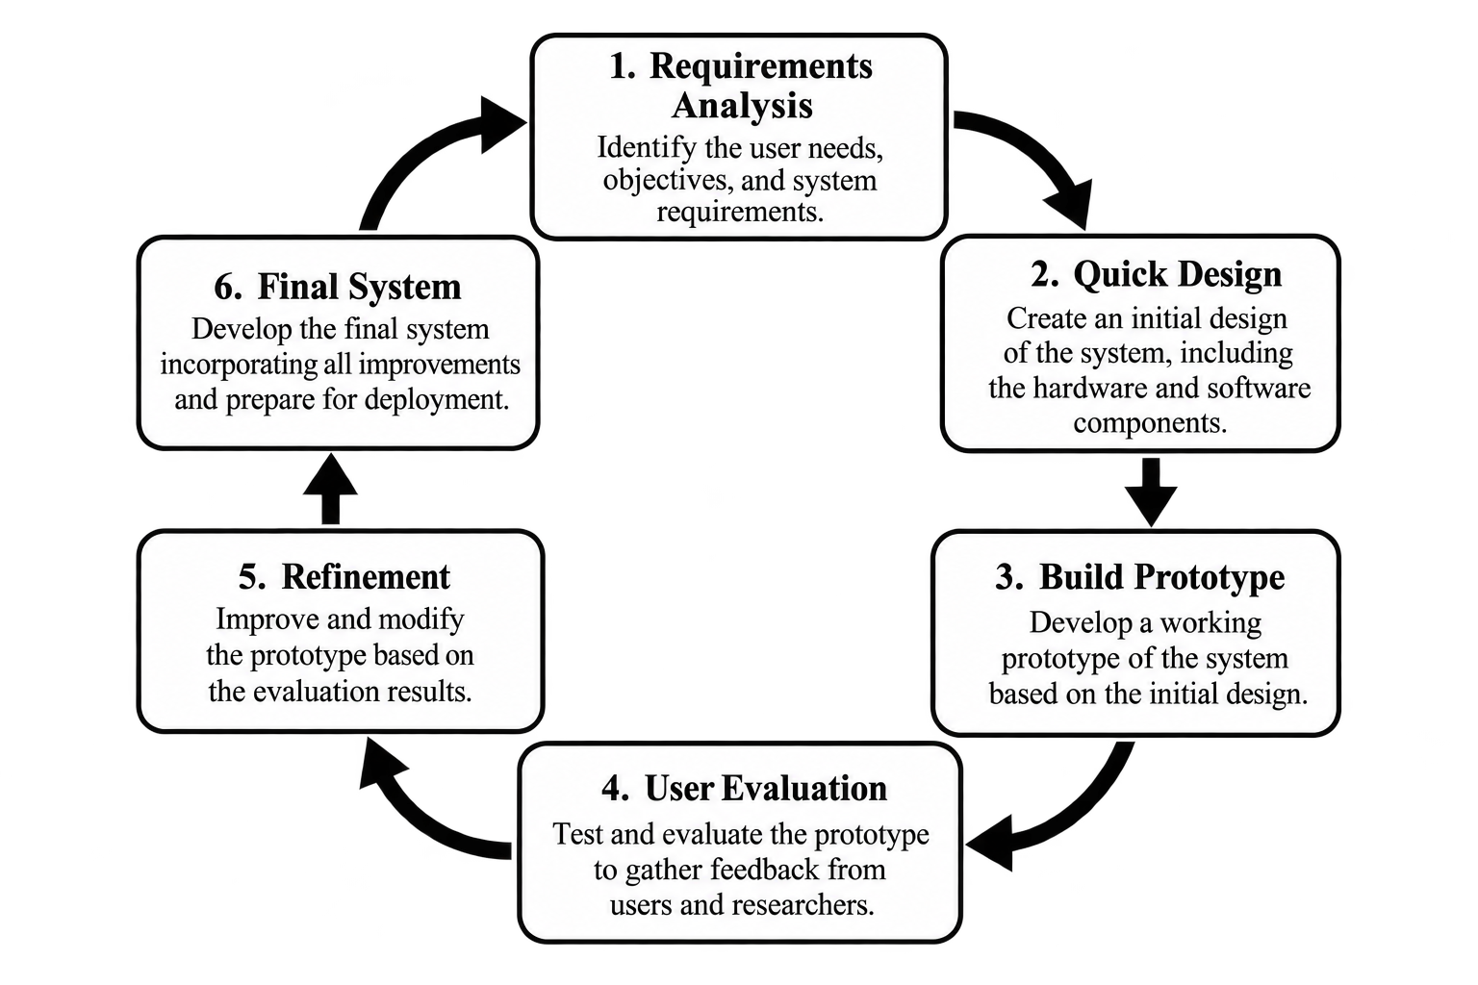
Figure 2.1.1. System Development Life Cycle (Prototyping Model)
The Prototyping Model will consist of the following phases:

1. Requirements Gathering and Analysis
In this phase, the researchers identify and analyze the requirements of Project FALCON based on the objectives of the study, related literature and studies, technical requirements, and the intended coastal monitoring functions of the prototype. The required measurements include water-pressure data for estimated wave height, wind speed, 0°–360° wind direction, GPS location, and available power and system-status information.
The researchers also define the required system capabilities, including sensor data acquisition, pressure-to-wave-height processing, local data storage, wireless transmission, cloud-based monitoring, dashboard presentation, short-term wave-height prediction, and continued data collection during temporary Internet interruptions. Functional requirements and non-functional requirements such as reliability, usability, power efficiency, data integrity, and maintainability are identified during this phase.

2. Quick Design
After the requirements are identified, a preliminary design is prepared to show how the major parts of Project FALCON will work together. The quick design includes the planned hardware configuration, sensor connections, ESP32-based processing, solar-battery power system, local data buffer, wireless communication, cloud data flow, dashboard layout, and AI-assisted prediction component.
This phase also identifies the basic software requirements, including firmware logic, communication procedures, data formatting, cloud storage structure, dashboard functions, and the method for handling records when Internet connectivity is unavailable. The purpose of the quick design is to provide an overall guide for prototype construction before the detailed system architecture and diagrams are finalized.
3. Build a Prototype
Using the quick design as the basis, the researchers construct the initial Project FALCON prototype. The prototype integrates the ESP32 microcontroller, submerged pressure sensor, wind-speed and wind-direction sensors, GPS receiver, solar-battery power subsystem, communication components, local data storage or buffering, and the physical buoy enclosure and support components.
The firmware is developed to collect and timestamp sensor readings, perform initial validation and processing, prepare pressure data for estimated wave-height calculation, organize monitoring records, and manage data transmission. The cloud platform and dashboard are also configured to receive, store, and display the transmitted information. The short-term wave-height prediction component is integrated using the environmental data available from the monitoring system.
4. Initial User Evaluation
The initial prototype is evaluated through bench testing, controlled water testing, communication testing, power testing, and limited near-shore validation when feasible and approved. The evaluation focuses on whether the prototype performs its intended functions, including sensor acquisition, estimated wave-height processing, wind monitoring, GPS reporting, local data storage, cloud transmission, recovery after Internet interruption, dashboard presentation, and prediction output.
Technical evaluators and intended reviewers may also assess the clarity and usability of the monitoring dashboard and system outputs. The purpose of this phase is to identify weaknesses, errors, or design issues that may affect the accuracy, reliability, usability, or overall performance of the system.
5. Refining Prototype
Based on the results of the initial evaluation, the researchers revise and improve the prototype. Modifications may include improving sensor calibration, filtering and wave-height processing, adjusting firmware logic, strengthening wireless data transmission, improving local buffering and recovery of queued records, refining solar-battery power management, improving dashboard presentation, and adjusting the short-term prediction component.
The prototype is retested after each significant modification. This iterative refinement continues until the system satisfies the agreed project requirements and the remaining limitations are clearly documented.
6. Implement Product and Maintain
Once the refined prototype has completed the required testing and validation, the researchers prepare the final Project FALCON prototype for the approved study implementation. This phase includes final system verification, documentation of the hardware and software configuration, preparation of operating procedures, and recording of maintenance requirements.
Maintenance considerations include sensor inspection and recalibration when required, battery and solar-power checks, firmware and cloud-service updates, inspection of communication and local-storage functions, and troubleshooting of hardware or software problems. The final prototype is intended for research and coastal environmental monitoring within the scope of the study and is not intended to replace official marine forecasting, navigation, or warning systems.

2.2 System Architecture / Framework
Project FALCON uses an integrated system architecture that connects the physical buoy, environmental sensors, ESP32 microcontroller, wireless communication, cloud services, and web-based monitoring dashboard. The architecture defines how data move from field sensing to remote monitoring and short-term wave-height prediction. It also shows how the solar-battery power system supports the buoy and how data are protected during temporary internet interruptions.

Conceptual Framework
The conceptual framework presents the iterative development process of Project FALCON. It begins with Research and Development, where relevant coastal-monitoring literature, ocean-parameter data, related buoy-monitoring studies, sensor and communication requirements, design requirements, and evaluation criteria are identified. These requirements guide the Prototyping stage, in which the hardware and software components of the smart buoy are integrated into a working system.
The Result stage represents the expected outputs of the prototype, including pressure-derived estimated wave-height records, wind-speed and wind-direction data, GPS and power-status records, scheduled summary packets, and cloud-dashboard outputs. The prototype then proceeds to Testing and Validation, where sensor accuracy, pressure-to-wave estimation, wind-data consistency, communication reliability, GPS accuracy, solar-battery performance, data integrity, and dashboard usability are evaluated. The findings are used as Feedback to identify hardware, software, or calibration problems, revise the design, and repeat testing when necessary. This cycle supports continuous improvement of Project FALCON until the prototype satisfies the requirements of the study.
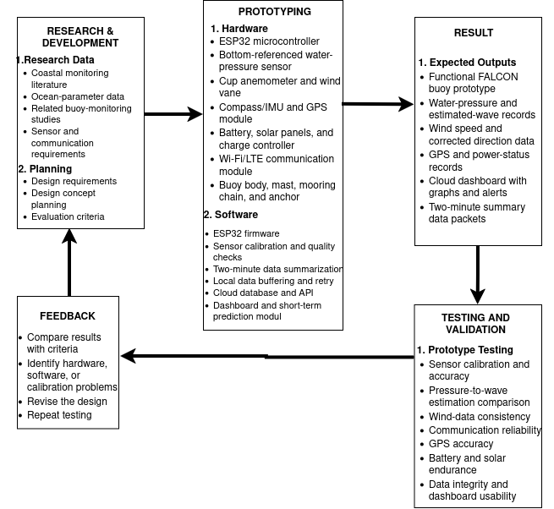
Figure 2.2.1. Conceptual Framework
Figure 2.2.1 shows the development cycle followed in Project FALCON. Research and planning define the requirements of the system; prototyping converts these requirements into integrated hardware and software; the resulting prototype is tested and validated against the study criteria; and the evaluation findings are returned as feedback for refinement. The framework therefore emphasizes an iterative process in which testing results guide improvements before the prototype is finalized.

Testing Rubrics
The following rubric defines the criteria and testing requirements that will be used to evaluate Project FALCON. Each criterion will be supported by recorded measurements, comparison data, system logs, or documented evaluator results during prototype testing and validation.
Evaluation Area | Criterion | Testing Requirement
Sensor Performance | Wave-Height Estimation Accuracy | Compare pressure-derived estimated wave height with an independent reference measurement and report MAE, RMSE, and mean bias.
Sensor Performance | Wind Measurement Consistency | Compare wind-speed and 0°–360° wind-direction readings with a suitable reference when available and document consistency, response, and observed error.
System Functionality and Reliability | Data Acquisition and Local Storage | Verify continuous sensor acquisition, correct timestamps, retention of raw pressure data, and generation of the defined two-minute summary records.
System Functionality and Reliability | Connectivity and Recovery | Conduct a controlled Internet interruption and measure successful uploads, upload delay, duplicate records, and recovery of locally queued records after connectivity is restored.
Power Performance | Solar-Battery Operation | Record battery voltage, average current or power use, charging behavior, operating runtime, and whether the solar-battery subsystem can support the prototype during the defined test period.
Data Integrity and GPS Reporting | Record Completeness and Position | Check timestamps, missing or duplicate records, data-order recovery, quality flags, and GPS position error against a trusted reference.
Usability | Dashboard Functionality and Usability | Verify that intended evaluators can view the required measurements, system status, historical records, and prediction results, and document identified usability issues.
Prediction Performance | Short-Term Wave-Height Prediction | Evaluate prediction results on held-out observations using MAE, RMSE, and mean bias, then compare them with the selected baseline prediction method before making an accuracy claim.
Table 2.2.1. Testing Rubrics

System Overview
The System Overview presents the operational flow of Project FALCON from environmental sensing at the buoy to remote monitoring through the cloud-based dashboard. The system is organized into five functional layers: Data Acquisition, Processing and Local Storage, Communication, Cloud Application and Data, and Presentation. These layers work together to collect environmental measurements, process and preserve records, transmit available data, generate monitoring and prediction outputs, and present the information to authorized users.
1. Data Acquisition Layer
The Data Acquisition Layer consists of the sensors and monitoring inputs installed in the buoy. The submerged pressure sensor collects water-pressure measurements used for estimated wave-height processing. The anemometer and wind vane measure wind speed and 0°–360° wind direction, while the GPS receiver provides location and available heading or motion information. Battery voltage, solar-charging status, and other available device-health information are also collected for system monitoring.

2. Processing and Local Storage Layer
The ESP32 serves as the main processing controller of Project FALCON. It collects and timestamps the sensor readings, performs initial validation and quality checks, applies the required calibration and filtering procedures, and prepares the pressure measurements for estimated wave-height processing. The controller also organizes the environmental and system-status records into the required data format.
Raw pressure samples and other required records are stored locally to support validation and data recovery. The system prepares a scheduled two-minute summary packet for transmission. If Internet connectivity is interrupted, data collection continues and the records remain in the local buffer with their original timestamps until the connection is restored.
3. Communication Layer
The Communication Layer transfers prepared records from the buoy to the cloud platform through the available wireless Internet connection, such as Wi-Fi or LTE, depending on the final prototype configuration. When connectivity is available, the current scheduled summary and any queued records are transmitted to the cloud. When connectivity is unavailable, the system does not stop sensing; instead, unsent records remain queued locally and are transmitted after the connection returns.
4. Cloud Application and Data Layer
The Cloud Application and Data Layer receives, stores, and manages the records transmitted by the buoy. The cloud database preserves the monitoring data for remote access, review, and analysis. The application layer supports the processing and presentation of estimated wave height, wind observations, GPS information, power and system status, and communication records.
The short-term wave-height prediction component operates using the available processed environmental data. Prediction results are stored with the monitoring records and will be evaluated against observed values and the selected baseline method as described in the testing procedure.
5. Presentation Layer
The Presentation Layer is the web-based monitoring dashboard used by the researchers and other authorized users. It presents the available estimated wave-height information, wind speed, 0°–360° wind direction, GPS location, power and system status, communication status, historical records, and short-term wave-height prediction results. The dashboard provides the user-facing view of the system while the lower layers continue sensing, processing, storing, and transmitting data.
[DIAGRAM PLACEHOLDER — Figure 2.2.2: Project FALCON System Overview. The final diagram will show the five-layer flow: Data Acquisition → Processing and Local Storage → Communication → Cloud Application and Data → Presentation, including the offline local-buffer and retransmission path.]
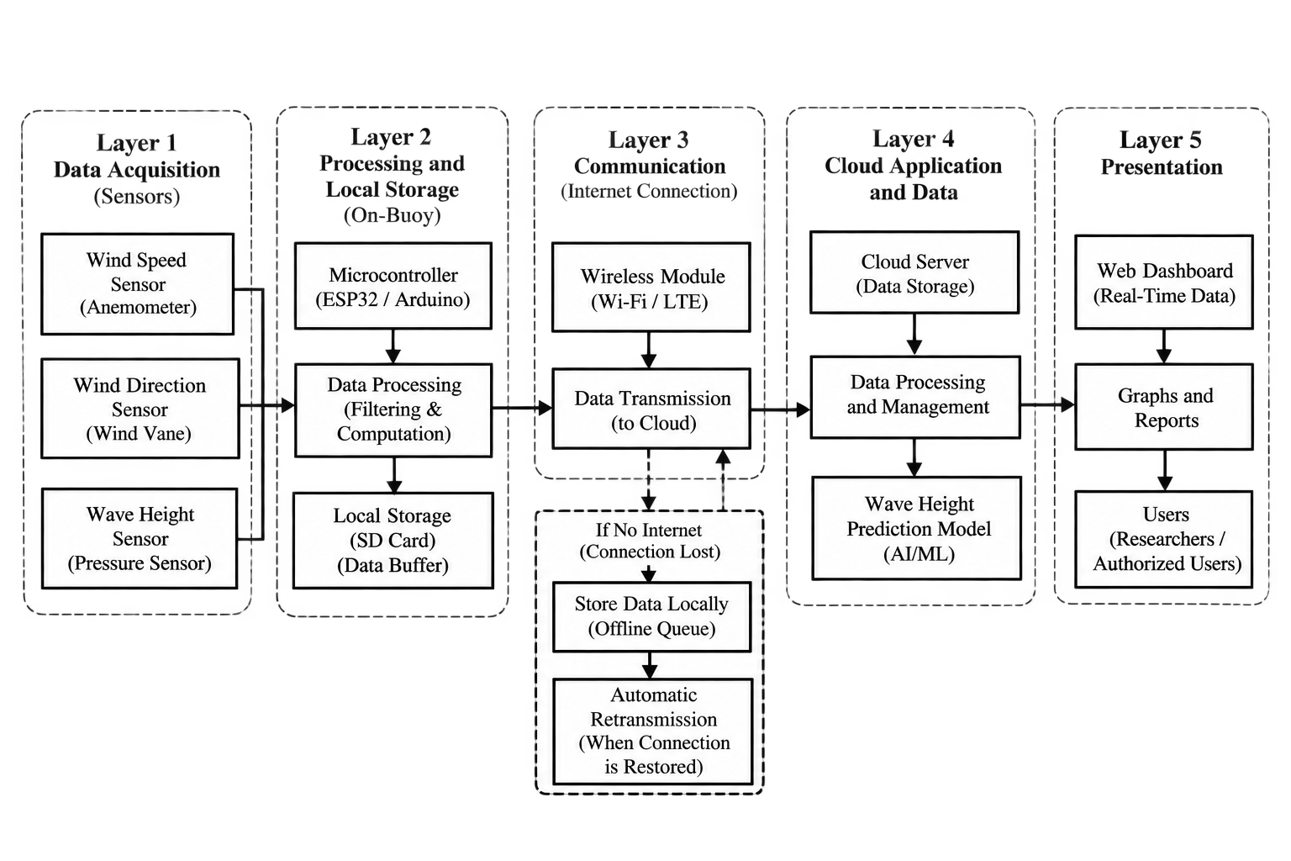
Figure 2.2.2. Project FALCON System Overview
Figure 2.2.2 will illustrate the complete operational flow of Project FALCON. Environmental and system-status data are acquired at the buoy, processed and stored locally by the ESP32, transmitted through the available Internet connection, managed by the cloud application and database, and presented through the monitoring dashboard. The diagram will also show that local data collection and storage continue during an Internet interruption and that queued records are transmitted after connectivity is restored.

System Design and Architecture
Hardware Block Diagram: The hardware block diagram presents the physical integration of Project FALCON: the ESP32 controller, submerged pressure sensor, anemometer and wind vane, GPS receiver, communication module, solar panels, LiFePO4 battery, charge controller, marine warning light, enclosure, and mooring assembly.
The ESP32 receives sensor readings, applies calibration and quality checks, stores raw and summary records locally, and prepares a scheduled two-minute summary for cloud upload. The power subsystem supplies and recharges the device, while the communication module transfers records to the cloud dashboard when Internet service is available.
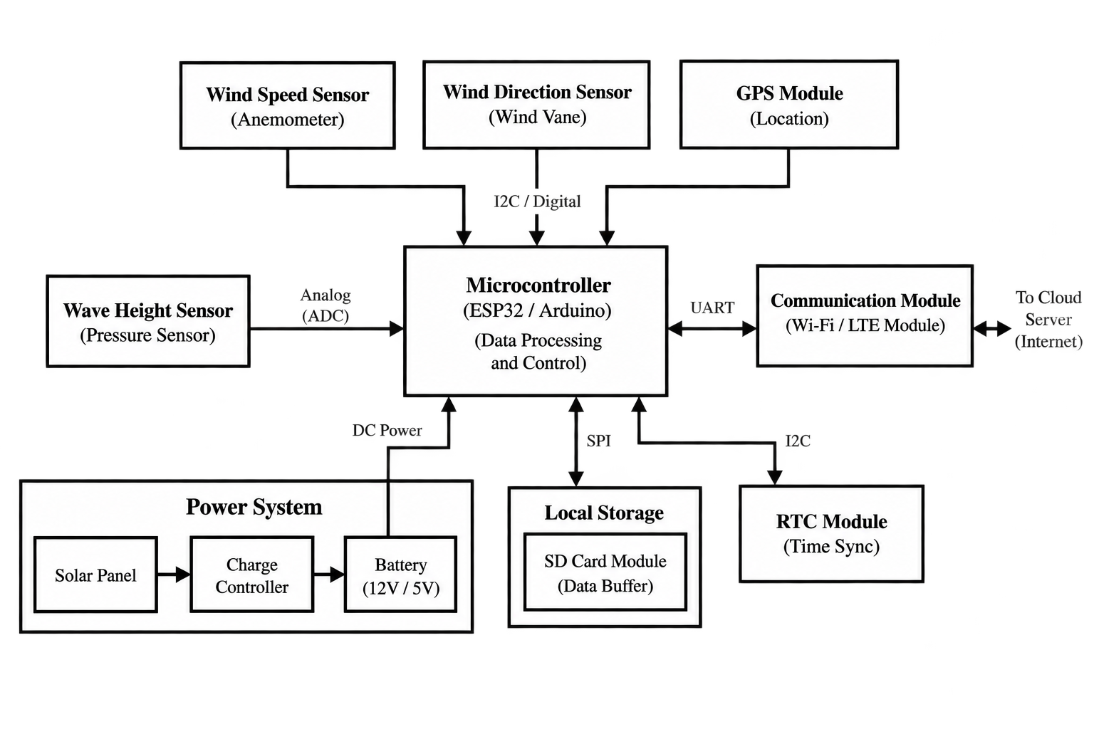
Figure 2.2.3. Project FALCON Hardware Block Diagram

System Flowchart
The system flowchart presents the operating process of Project FALCON, from startup to continuous monitoring. The process begins when the device is turned on and the ESP32, sensors, local storage, and communication functions are prepared. The system checks whether all required components are working properly before collecting data. If a component is not ready, the system records the problem and tries to start the component again before continuing.
During normal operation, the ESP32 continuously collects water-pressure, wind-speed, 0°–360° wind-direction, GPS receiver, power-status, and available system-health data. Each reading is timestamped, checked for validity, and processed according to the required calibration and filtering procedures. Pressure measurements are prepared for estimated wave-height calculation, while raw pressure samples and the required monitoring records are stored in the local buffer for validation and recovery.
The system then checks whether the current two-minute reporting window is complete. If the window is not yet complete, data acquisition continues. When the two-minute window is complete, the ESP32 prepares a summary packet containing the required environmental and system-status information.
Before transmission, the system checks Internet connectivity. If connectivity is available, the current summary packet and any previously queued records are transmitted to the cloud platform while preserving their original timestamps and record order. The cloud platform stores the received data, supports the short-term wave-height prediction process, and makes the monitoring and prediction results available to the web-based dashboard.
If Internet connectivity is unavailable, the system does not stop collecting data. The unsent summary remains stored in the local queue, and the device continues sensing, processing, timestamping, and saving new records. Connectivity is checked again during subsequent transmission attempts. Once the connection is restored, queued records are transmitted to the cloud before the system resumes normal scheduled uploads.
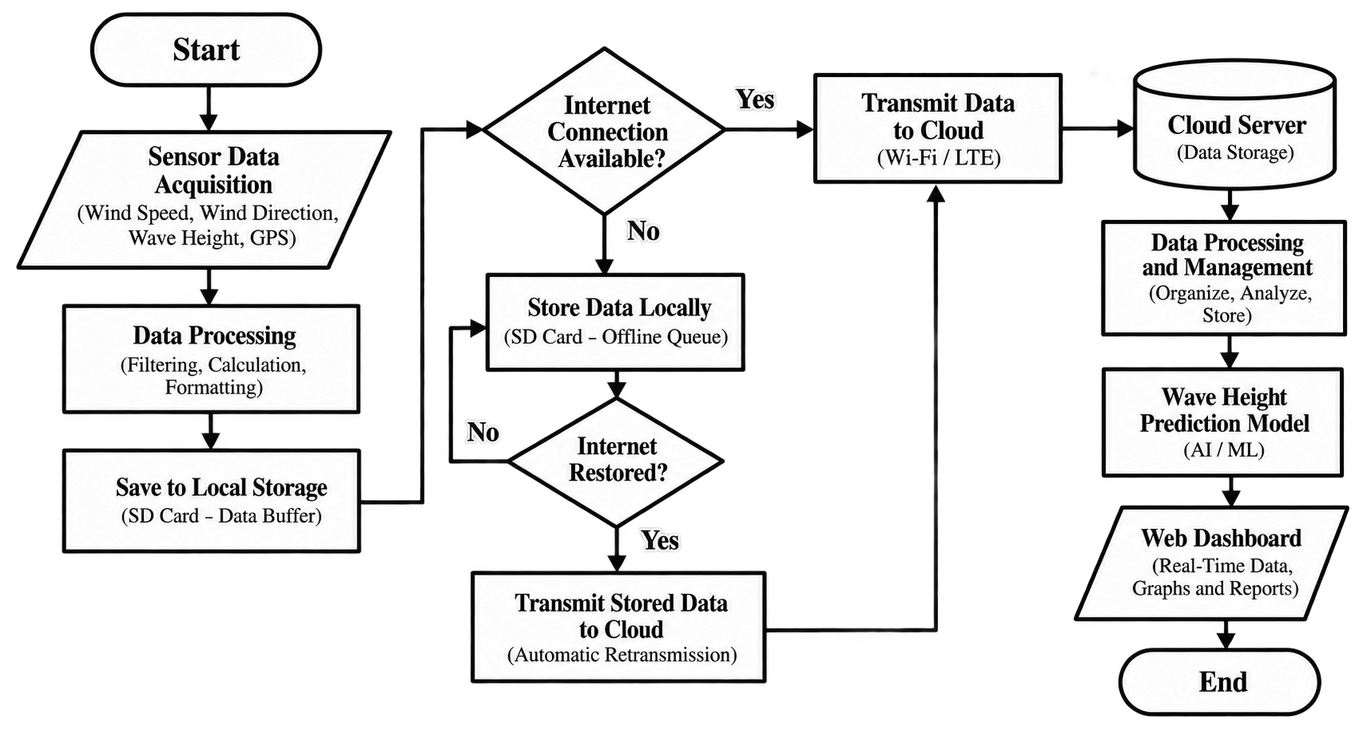
Figure 2.2.4. Project FALCON System Flowchart
Figure 2.2.4 will illustrate the complete operating logic of Project FALCON. The flow emphasizes that sensing and local data storage continue even during an Internet interruption. Cloud transmission is treated as a separate decision in the operating cycle, allowing unsent records to remain queued until connectivity is restored. After successful transmission, cloud storage, prediction, and dashboard presentation are updated while the buoy continues the next monitoring cycle.
2.3 Data Collection Methods
Data Collection Activity | Sensor or Module | Output or Action
Water-pressure acquisition | Submerged pressure sensor and ESP32 | Timestamped raw pressure samples retained in the local buffer for pressure-to-wave analysis.
Wind observation | Anemometer and wind vane | Wind-speed and 0°–360° wind-direction observations summarized for each reporting window.
Position and buoy status | GPS receiver and ESP32 | GPS position, timestamp, geofence/security status, and device-health information.
Power monitoring | 12.8 V 10 Ah LiFePO4 battery with BMS, LiFePO4-compatible solar charge controller, six 5 W compact solar panels (30 W total), fuse, and ESP32. | Battery voltage, solar-charging status, power-related quality flags, and measured charge/discharge performance.
Scheduled transmission | Communication module and cloud service | One summary packet is uploaded at the end of each two-minute window; queued records are recovered after connectivity returns.
Table 2.3.1. Data Collection Methods
Project FALCON will collect five groups of data: water-pressure measurements, wind observations, GPS and buoy-status data, power-status data, and system communication records. Each record will include a timestamp, unit, source, and quality status.
The pressure sensor will be sampled locally at the proposed validation rate of 4 Hz. The ESP32 will also record wind speed, wind direction, GPS position, timestamp, geofence/security status, battery voltage, solar-charging status, sensor health, and communication status.
The buoy will continuously collect readings during operation and transmit one routine summary packet at the end of every two-minute window. The two-minute packet will contain pressure-derived wave statistics, wind-speed and direction summaries, GPS position, battery and solar status, quality flags, and the beginning and ending timestamps of the sampling window. An immediate event packet will be sent only when a validated pressure, wind, GPS/geofence, power, sensor-health, tamper, or connectivity-recovery threshold is reached. Ordinary wave motion alone will not trigger repeated event transmission.
Raw pressure samples will be retained in the local buffer so that the pressure-to-wave calculation can be recalculated and compared with an independent reference instrument. If the Internet connection is unavailable, the ESP32 will store the records locally with their original timestamps and transmit them after the connection is restored.
Data collection will be performed in three stages:
- Bench testing – verification of sensor wiring, calibration, timestamps, data formatting, local storage, and communication.
- Controlled water testing – testing of pressure response using a measured water column or controlled water movement.
- Limited near-shore validation, when feasible – comparison of the buoy measurements with suitable reference readings under an approved and supervised test plan.
The final collection interval, pressure-sensor calibration, buffer capacity, and communication configuration will be confirmed during prototype testing. Until these tests are completed, the values remain proposed design parameters and will not be presented as field-validated results.

2.4 Software and Tools Used
Tools for Building Project FALCON
The development of Project FALCON requires hardware and software tools for environmental sensing, local processing, power management, data storage, wireless communication, cloud monitoring, and short-term wave-height prediction. The tools listed below represent the planned components and development resources of the prototype. Specific brands or models may be adjusted after procurement, compatibility checking, and prototype validation.
Tool or Component | Purpose
ESP32 development board | Serves as the main controller for sensor acquisition, timestamping, local processing, buffering, and preparation of records for transmission.
Submersible pressure sensor with stilling tube and required signal interface | Measures water-pressure variation used for pressure-based estimated wave-height processing and validation.
Anemometer and wind vane | Measure wind speed and 0°–360° wind direction for coastal-condition monitoring and prediction inputs.
GPS receiver module | Provides buoy location and available heading or motion information for monitoring and data interpretation.
Local storage or buffer | Retains raw pressure samples and queued monitoring records so data collection can continue during temporary Internet interruption.
Six 5 W compact solar panels (30 W total), 12.8 V 10 Ah LiFePO4 battery with BMS, and LiFePO4-compatible charge controller | Supply renewable electrical power, protected battery charging, and stored energy for buoy operation.
Wireless communication module | Provides the available Wi-Fi or LTE data connection used to transmit scheduled records and recover queued records after connectivity returns.
Cloud database and web-based dashboard tools | Receive, store, organize, visualize, and provide remote access to monitoring records and short-term prediction outputs.
PlatformIO or Arduino IDE, firmware libraries, and web-development tools | Support firmware development, sensor integration, communication logic, local buffering, cloud services, dashboard functions, and system testing.
Table 2.4.1. Tools for Building Project FALCON

Tools for Testing and Developing the Project
The following testing and evaluation tools will be used to verify the performance of the prototype. These tools support sensor comparison, controlled testing, power measurement, communication testing, GPS checking, dashboard evaluation, and analysis of wave-height and prediction errors.
Testing or Evaluation Tool | Purpose
Independent wave-height reference or controlled water-level setup | Provides comparison measurements for evaluating pressure-derived estimated wave height during controlled and approved tests.
Suitable wind-speed and wind-direction reference, when available | Supports comparison and consistency checking of anemometer and wind-vane readings.
Multimeter or power meter | Measures battery voltage, current or power use, charging behavior, and other electrical values used in solar-battery evaluation.
Trusted GPS reference source | Supports checking of recorded buoy position and calculation of observed GPS position error.
Network and communication logs or test tools | Record upload success, latency, interruption behavior, duplicate records, and recovery of queued data after connectivity is restored.
Dashboard task sheet or usability evaluation form | Documents whether intended evaluators can view required measurements, system status, historical records, and prediction outputs clearly and correctly.
Data-analysis or spreadsheet tools | Calculate and summarize testing metrics such as MAE, RMSE, mean bias, completeness, and other recorded performance results.
Table 2.4.2. Tools for Testing and Evaluating Project FALCON
2.5 Development Procedures
Project FALCON will be developed through an iterative prototyping procedure. Each stage will produce a working output that can be checked, improved, and retested before proceeding to the next stage.
- Requirements Gathering and Analysis
The researchers will identify the coastal-monitoring requirements, operational constraints, available budget, required sensor measurements, data fields, communication options, power requirements, deployment considerations, and evaluation criteria for the prototype.
- Quick Design
The researchers will prepare the initial buoy configuration, hardware block diagram, system flowchart, firmware logic, power arrangement, data structure, dashboard layout, local-storage and recovery logic, and testing plan. The design will serve as the basis for the first working prototype.
- Build and Integrate the Prototype
The ESP32, pressure sensor and required signal interface, wind-speed and wind-direction sensors, GPS receiver, local storage, solar-battery subsystem, communication module, enclosure, mast, and mooring components will be assembled and integrated. Firmware, cloud storage, dashboard functions, and the short-term wave-height prediction component will be connected to the prototype as development progresses.
- Calibrate and Verify the System
Sensor readings and power measurements will be checked against suitable reference measurements. The pressure-to-estimated-wave-height processing, wind data, timestamps, GPS location, local data storage, two-minute data summarization, cloud upload, and dashboard display will be verified before field-oriented testing. Internet-interruption tests will also confirm that data collection continues locally and that queued records are transmitted after connectivity is restored.
- Conduct Prototype Testing and Evaluation
The integrated prototype will undergo bench tests, controlled-water tests, communication-outage and recovery tests, power tests, dashboard and data-integrity checks, and limited near-shore testing when feasible and approved. The short-term wave-height prediction component will be evaluated using collected observations and appropriate error measures. Results will be recorded using the established testing criteria.
- Refine, Retest, and Finalize the Prototype
Test results and evaluator feedback will be reviewed to identify problems in sensor calibration, firmware, connectivity, power operation, data handling, enclosure or mechanical design, dashboard presentation, and prediction performance. Necessary revisions will be applied, followed by repeated testing until the prototype reaches the acceptable performance level defined for the study. The final configuration, procedures, limitations, and test results will then be documented.

2.6 Testing and Evaluation
The testing and evaluation phase will be conducted after the development of Project FALCON, a solar-powered smart buoy for pressure-based wave monitoring and short-term prediction. This phase aims to determine whether the developed prototype operates according to its intended functions and requirements. The evaluation will focus on measurement accuracy, communication reliability, power performance, data integrity, usability, and prediction performance.
Through different testing methods, the researchers will assess the system's ability to collect wave and wind data, transmit sensor readings to the cloud-based dashboard, operate using solar power, and generate short-term wave-height predictions.
Functional Testing
Functional testing will be conducted to verify whether the main features of Project FALCON operate correctly according to the system requirements. This will include testing the pressure sensor for wave monitoring, the wind sensor for measuring wind speed and direction, the ESP32 for processing sensor readings, the GPS module for recording location, and the dashboard for displaying collected data. The researchers will also check whether the prediction component produces wave-height predictions using the available data.
Integration Testing
Integration testing will be performed to determine whether the hardware and software components work together properly. This will include checking the connection between the sensors, ESP32, GPS module, solar-powered electrical system, communication module, data storage, cloud-based dashboard, and prediction component. The researchers will verify whether sensor readings are processed, transmitted, stored, and displayed correctly throughout the system.
Measurement Accuracy Testing
Measurement accuracy testing will be conducted to evaluate the accuracy of the wave-height estimates and wind measurements. The wave-height estimates obtained from the pressure sensor will be compared with measurements from a suitable reference instrument. Wind speed and wind direction readings will also be compared with reference measurements. The Mean Absolute Error (MAE), Root Mean Square Error (RMSE), and Mean Bias Error (MBE) will be used, where applicable, to determine the differences between the system's readings and the reference values.
Communication Reliability Testing
Communication reliability testing will assess whether Project FALCON can transmit sensor readings to the cloud-based dashboard successfully. The researchers will record the number of data packets sent and received, measure the time required to upload data, and check whether temporarily stored records can be recovered after a communication interruption. These tests will help determine the reliability of data transmission and the system's ability to preserve collected records.
Power Performance Testing
Power performance testing will evaluate whether the solar panel and rechargeable battery can support the operation of the buoy's electronic components under the tested conditions. The researchers will measure voltage and current, estimate energy consumption, and observe battery charging behavior and operating duration. If solar energy supplied and system energy consumed can be measured separately, the researchers will compare these values to assess the system's energy balance.
Data Integrity and GPS Testing
Data integrity testing will determine whether sensor readings are recorded completely and stored without unintended duplication. The researchers will check the number of expected, valid, missing, and duplicate records. GPS testing will compare the coordinates recorded by the GPS module with a suitable reference position to estimate the location error. These tests will help assess the completeness and consistency of the collected data.

Prediction Performance Testing
Prediction performance testing will evaluate how accurately Project FALCON predicts short-term wave height. The predicted values will be compared with corresponding actual wave-height measurements from the reference dataset. The researchers will use MAE, RMSE, and MBE to assess prediction errors. The developed prediction model will also be compared with a simple baseline that uses the latest available wave-height observation as the prediction for the next time step. The evaluation will use separate test data that were not used to train the model.
Usability Testing
Usability testing will assess whether intended users can understand and use the cloud-based dashboard to view wave-height estimates, wind measurements, GPS information, and prediction results. Selected users may be asked to perform basic dashboard tasks and provide feedback through a questionnaire. The feedback will help the researchers identify difficulties in viewing or interpreting the displayed information and determine areas for improvement.

2.7 Ethical Considerations
Participation will be voluntary and based on an informed-consent form written in understandable language. The form will explain the purpose, activities, expected duration, possible inconvenience, absence of guaranteed direct benefit, confidentiality measures, and contact person. Participants may refuse any question or stop before submission without penalty. Recruitment will avoid coercion, and supervisors or researchers will not pressure students, employees, or community members to join.
The study will collect only the participant information needed for eligibility and analysis. Names and contact details will be separated from response data and replaced with codes. Access will be limited to the research team and adviser. Electronic files will use controlled access and encrypted storage where available; printed consent forms will be kept separately in a secured location. Public datasets and screenshots will exclude personal identifiers, account details, exact sensitive coordinates, credentials, and SIM information. Records will be retained through the final defense and for one year afterward, unless the institution requires a different period, and will then be securely deleted or destroyed in accordance with the Data Privacy Act of 2012 (Republic Act No. 10173, 2012).
Field activities will follow a written safety and retrieval plan. The prototype will not be deployed during severe weather, in a navigation channel, or without an approved mooring and responsible on-site supervision. The dashboard will display experimental, stale, simulated, calibration-required, and unavailable labels as applicable. Participants will be told that FALCON is not an official warning or navigation instrument and that safety decisions must use authorized government information.
Results will be disseminated through the thesis manuscript and defense, an adviser-approved technical report, and a concise findings letter or presentation for DOST, Fullbright College, the participating barangay or local office, and other approved partners. Publication or conference presentation may follow institutional approval. Reports will include unsuccessful tests and limitations, will avoid identifying participants, and will not reveal sensitive deployment information that could increase theft or interference risk.

References
Benfell, A. (2021). Modeling functional requirements using tacit knowledge: A design science research methodology informed approach. Requirements Engineering, 26, 25-42. https://doi.org/10.1007/s00766-020-00330-4
Department of Science and Technology-Advanced Science and Technology Institute. (2024). 2024 annual report. https://asti.dost.gov.ph/wp-content/uploads/2024-DOST-ASTI-Annual-Report.pdf
Giraldo, L. F., et al. (2022). Open-source low-cost design of a buoy for remote water quality monitoring in fish farming. PLOS ONE, 17(6), e0270202. https://doi.org/10.1371/journal.pone.0270202
Hasan, A., Kayes, I., Alam, M., Shahriar, T., & Habib, M. A. (2024). Generalized machine learning models to predict significant wave height utilizing wind and atmospheric parameters. Energy Conversion and Management: X, 23, 100623. https://doi.org/10.1016/j.ecmx.2024.100623
Hou, B., Fu, H., Li, X., Song, T., & Zhang, Z. (2024). Predicting significant wave height in the South China Sea using the SAC-ConvLSTM model. Frontiers in Marine Science, 11, 1424714. https://doi.org/10.3389/fmars.2024.1424714
Intergovernmental Oceanographic Commission of UNESCO. (2025). Global Ocean Observing System 2025 status report. Global Ocean Observing System. https://goosocean.org/news/goos-status-report-2025-released/
Lyman, T. P., Elsmore, K., Gaylord, B., Byrnes, J. E. K., & Miller, L. P. (2020). Open Wave Height Logger: An open source pressure sensor data logger for wave measurement. Limnology and Oceanography: Methods, 18(7), 335-345. https://doi.org/10.1002/lom3.10370
Madarcos, K. G., Alcantara, L. B., & Creencia, L. A. (2026). Perceived climate change impacts on food security in coastal communities of Puerto Princesa City, Philippines. UCL Open Environment, 8, e3512. https://doi.org/10.14324/111.444/ucloe.3512
Pacaldo, J. C., Bilgera, P. H. T., & Abundo, M. L. S. (2022). Nearshore wave energy resource assessment for off-grid islands: A case study in Cuyo Island, Palawan, Philippines. Energies, 15(22), 8637. https://doi.org/10.3390/en15228637
Republic Act No. 9729. (2009). Climate Change Act of 2009. Supreme Court E-Library. https://elibrary.judiciary.gov.ph/thebookshelf/showdocs/2/18615
Republic Act No. 10121. (2010). Philippine Disaster Risk Reduction and Management Act of 2010. Supreme Court E-Library. https://elibrary.judiciary.gov.ph/thebookshelf/showdocs/2/21121
Republic Act No. 10173. (2012). Data Privacy Act of 2012. Official Gazette of the Republic of the Philippines. https://officialgazette.gov.ph/2012/08/15/republic-act-no-10173/
Republic Act No. 10692. (2015). PAGASA Modernization Act of 2015. Supreme Court E-Library. https://elibrary.judiciary.gov.ph/thebookshelf/showdocs/2/65229
Shen, W., Ying, Z., Zhao, Y., & Wang, X. (2024). Significant wave height prediction in monsoon regions based on the VMD-CNN-BiLSTM model. Frontiers in Marine Science, 11, 1503552. https://doi.org/10.3389/fmars.2024.1503552
Tahera, K., Wynn, D. C., Earl, C., & Eckert, C. M. (2019). Testing in the incremental design and development of complex products. Research in Engineering Design, 30, 291-316. https://doi.org/10.1007/s00163-018-0295-6
Trevathan, J., & Schmidtke, S. (2022). Open-source Internet of Things remote aquatic environmental sensing. HardwareX, 12, e00336. https://doi.org/10.1016/j.ohx.2022.e00336
Williams, Z., Soto Calvo, M. A., Lee, H. S., Aljber, M., & Jeong, J.-S. (2025). A low-cost autonomous multi-functional buoy for ocean currents and seawater parameter monitoring, and particle tracking. Journal of Marine Science and Engineering, 13(9), 1629. https://doi.org/10.3390/jmse13091629

APPENDIX A
LETTER TO THE DEAN (SAMPLE)
< d a t e >
Jezree B. Vicente, PhD
Dean, College of Criminal Justice Education
Fullbright College
San Jose, Puerto Princesa City
Dear Dean Vicente:
A pleasant day.
The undersigned are students of <state your course in full> and are currently writing a thesis entitled <state the title of your thesis in full text>.
In this regard, may we ask permission from your office to commence the data gathering. Upon the approval of your office of this letter, the undersigned researchers will make a letter to the concerned key persons to coordinate the data gathering.
Thank you.
Respectfully yours.
<leave 4 spaces>
Firstname M.I. Surnames (same with the arrangement in the title page) Researchers
Recommended by:
Firstname M.I. Surname Firstname M.I. Surname Subject Instructor Adviser
Approved:
Jezreel B. Vicente, PhD
Dean

APPENDIX B
LETTER TO THE CITY DIRECTOR, PPCPO
<date>
PCOL CRISTINE M TABDI
City Director
Puerto Princesa City Police Office
Puerto Princesa City
Dear Sir:
The undersigned are students of <state your course in full> and are currently writing a thesis entitled <state the title of your dissertation in full text> as the terminal requirement to finish the degree. The purpose of this research is to <state the main purpose only.>
Relative to this research, may we ask permission from your good office for us to administer the questionnaires, conduct interviews with selected personnel. Rest assured that we will abide by the rules of ethics of research and bound by the rules of confidentiality as we gather the data. We will only use the data for research purposes. Thank you.
Respectfully yours.
<leave 4 spaces>
Firstname M.I. Surnames (alphabetical based on surnames)
Researchers
Noted by:
Firstname M.I. Surname
Adviser
Noted by:
Jezreel B. Vicente, PhD Dr. Edgardo Castillo
Dean, CCJE Dean, Research and Extension Approved:
Eleuterius L. Edualino
President, Fullbright College

APPENDIX C
LETTER TO THE RESEARCH PARTICIPANTS
<date>
Dear <Respondent/Informant>,
The undersigned are students of <state your course in full> and are currently writing a thesis entitled <state the title of your thesis in full text> as the terminal requirement to finish the degree. The purpose of this research is to <state the main purpose only.>
In this regard, may we request you to answer the attached <questionnaire / interview questions> about our study. Rest assured that the data collected will be used solely for this research without compromising the confidentiality and integrity of the agency you represent.
You have the right to refuse to participate in this research study. Also, you have the right to withdraw the information you provided to the researchers.
Thank you.
Respectfully yours.
<leave 4 spaces>
Firstname M.I. Surname (same arrangement in the title page) Researchers
Recommended by:
Firstname M.I. Surname Firstname M.I. Surname Research Instructor Adviser
Approved:
Jezreel B. Vicente, PhD
Dean

APPENDIX D
RESEARCH TOOL
If you used a questionnaire and/or an interview guide, attach them in this section. Do not create a separate appendix for each instrument. If you used two instruments, include both in this appendix and clearly label each one.

APPENDIX E
CERTIFICATION OF RESEARCH TOOL VALIDATION
CERTIFICATION OF RESEARCH TOOL VALIDATION
This is to certify that the research instrument titled: __________________ ________________________________________________________________ has been thoroughly reviewed and validated by the undersigned, serving as the Subject Instructor and the Research Adviser, respectively, to ensure its content validity, relevance, clarity, and appropriateness to the research objectives and questions of the study.
After careful examination, the tool was found to be appropriate and acceptable for data gathering purposes in partial fulfillment of the requirements for the degree of <Bachelor of Science in Criminology>
Validated this ___ day of _________, 2025, at Fullbright College, Puerto Princesa City, Palawan.
VALIDATORS:
Firstname M.I. Surname
Research Instructor
(Signature over Printed Name)
Firstname M.I. Surname
Research Adviser
(Signature over Printed Name)

APPENDIX F
PHOTO DOCUMENTATION

INSTRUCTIONS:
In this appendix, attached 3 photos during the:
a. Consultative Meeting of researchers (with caption)
b. Consultative Meeting with the adviser (with caption)
c. Consultative meeting with the research teacher (with caption)

